**Breeding Bird Monitoring Protocol for the Heartland Inventory and Monitoring Network**

**Standard Operation Procedure 10: Revising the Protocol**

**Version 3.00 (03/17/2020)**

**Revision History Log:**

|  |  |  |  |  |  |
| --- | --- | --- | --- | --- | --- |
| Previous Version # | Revision Date | Author | Changes Made | Reason for Change | New Version # |
| 1.01 | May 2008 | D.G. Peitz | Entire document | Edited to reflect that bird monitoring has been expanded to ten additional network parks | 2.00 |
| 2.00 | May 2019 | D.G. Peitz | Updated throughout to NRSS format. | Edited to meet I&M Division Protocol Review Guidance. Made SOP NRSS compliant. | 3.00 |
|  |  |  |  |  |  |
|  |  |  |  |  |  |
|  |  |  |  |  |  |

Inventory and Monitoring Division Protocol Review Guidance (Mitchell et al. 2018) provides thorough guidance for conducting protocol reviews and for revising protocols. A brief summary is provided here. Guidance prescribes two categories of protocol reviews, operational and scientific. Operational reviews may, and scientific reviews will, result in changes to the protocol narrative, SOPs, or QAP. Within the scientific review category, guidance defines three levels of review – targeted, full protocol, and multi-protocol. “A targeted protocol review typically addresses one or two goals, in a rapid manner designed to minimize interference with ongoing network operations. A full protocol review is more time consuming and takes a holistic and in-depth look at the protocol, while a multi-protocol review looks at the larger program and how the protocols interrelate to provide scientists and managers with scientifically sound information” (Table 10.01, Mitchell et al. 2018). Operational reviews are conducted annually and documented through the annual reporting process (See SOP #8). Scientific reviews are conducted as needed (See Table 10.01).

**Table 10.01.** Types of reviews covered by this guidance and basic characteristics of each. NPM = Network Program Manager, RPM = Regional Program Manager. Taken from Mitchell et al. (2018).

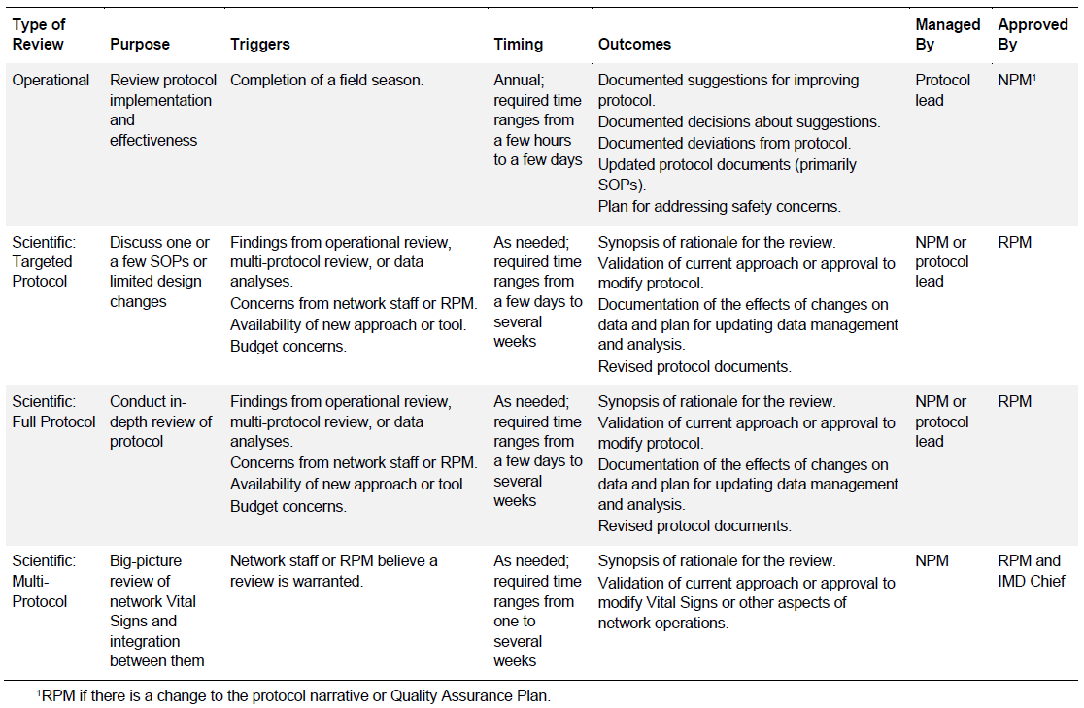

**Scientific Review Required Outcomes – Taken from Mithcell et al. (2018)**

1. Brief synopsis of rationale for the scientific review. Concisely describe the issue or concern that the scientific review is investigating. This could range from a general desire to ensure the scientific validity of a protocol to a specific issue that needs to be addressed.

2. For targeted and full protocol reviews, validation of current protocol objectives, design, methods, and standards (as appropriate for the type of scientific review), or recommendation to modify the protocol based on the findings of the scientific review. For example, a targeted review may only require validation or modification of some specific methods. In some situations, additional expert guidance regarding proposed changes may be needed before a decision can be approved. In this case the outcome will be an approved plan outlining the steps and timeline for making a decision.

3. If a recommendation is made to modify a protocol:

a. Documentation of any effects on data quality, data usability, or data quality standards, including whether (and how) data collected prior to protocol changes will be compatible with data collected after the changes.

b. Plan (tasks and timeline) for updating data management processes, revising the protocol database, flagging affected data, updating analysis methods, and updating reporting (as appropriate) to accommodate the changes.

c. Revised protocol documents suitable for peer review, or a plan (tasks and timeline) to accomplish the revisions.

4. For full protocol and multi-protocol reviews, an additional outcome is validation of current operations, or approval to modify the protocol(s) to improve information dissemination (what is being produced, in what formats, and how is it being made available) and support intended scientific and decision-support needs. If modifications are approved, an approved plan (tasks and timeline) for accomplishing the modifications is needed.

5. For multi-protocol reviews, an additional outcome is validation of the current suite of vital signs, or recommendation to modify the vital signs monitoring plan to improve the ability of the network to provide sound science to support park management. If monitoring plan changes are approved, a schedule of tasks and timelines for accomplishing the changes must be approved.

**Protocol Revision Documentation**

1. Publication

a. The narrative is published as a NPS Natural Resource Reports, and if it has changed the revised versions need to be submitted to the Natural Resource Publications Management Office (https://www.nps.gov/im/report-procedures.htm) for a new report number.

b. Each Standard Operating Procedure (SOP) and Quality Assurance Plan (QAP) is uploaded as a unique record to the Integrated Resource Management Application (IRMA) with the reference type set to Standard Operation Procedure or Quality Assurance Plan. (Note: SOPs and QAPs are not published in the NPS Natural Resource Publication Series.)

c. Each SOP and QAP record is linked to the protocol narrative record in IRMA using the External Link feature (Figure 10.01)

i. Open the protocol narrative record in IRMA.

ii. Click on the Files and Links tab

iii. Click the add button and choose external link.

iv. Provide the URL to the SOP or QAP record and type in a description

v. Repeat for each SOP or QAP

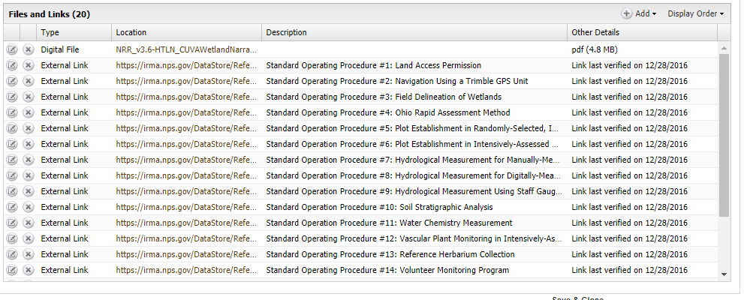

Figure 10.01. Example of a protocol narrative record in IRMA with external links to standard operating procedures.

2. Archiving—The network program manager ensures that review-related documents are organized and stored in a readily discoverable location on the network’s server.

3. Protocol tracking database—The network program manager is responsible for updating information about the protocol in the I&M protocol tracking database (<https://irma.nps.gov/protocoltracking/>).

**References**

Mitchell, B., A. Chung-MacCoubrey, J. Comiskey, L. Garrett, M. MacCluskie, B. Moore, T. Philippi, G. Sanders and J.P. Schmit. 2018. Inventory and Monitoring Division protocol review guidance. Natural Resource Report NPS/NRSS/IMD/NRR—2018/1644. National Park Service, Fort Collins, Colorado.